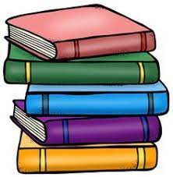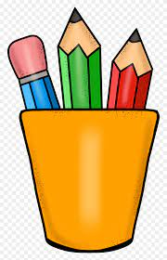

***Kindergarten Supply List***

Backpack

Lunchbox

Pencils

Pencil Sharper

Water bottle

Pair of Scissors

Box of Crayons

Pack of Erasers

Headphones

Glue Sticks

Folder

*A change of clothes for the classroom

**Classroom Supplies**

Box of tissues

Papertowels

Wipes

**Optional**

Dry Erase Markers

Water Bottles